Challenge on Terraform
Write a code using Terraform that deploys and achieves the following:-
- Create an EC2 Instance on AWS Cloud using the below-mentioned ubuntu AMI and instance_type. Or, (You can use of your choice as well) ami = "ami-0461b1436c9b3c1a3" instance_type = "t2.micro"
Created a main.tf file
Few instance type are not eligible to free tire soo I have used t3.micro
And I copied ami id from my console
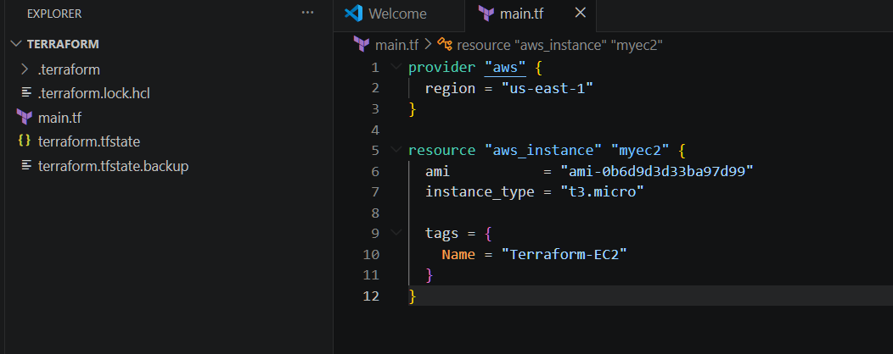
Then performed
terraform init
terraform validate
terraform paln
terraform apply
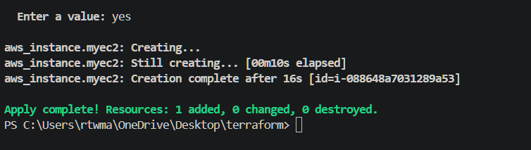

We have successfully created an instance as per our requirement
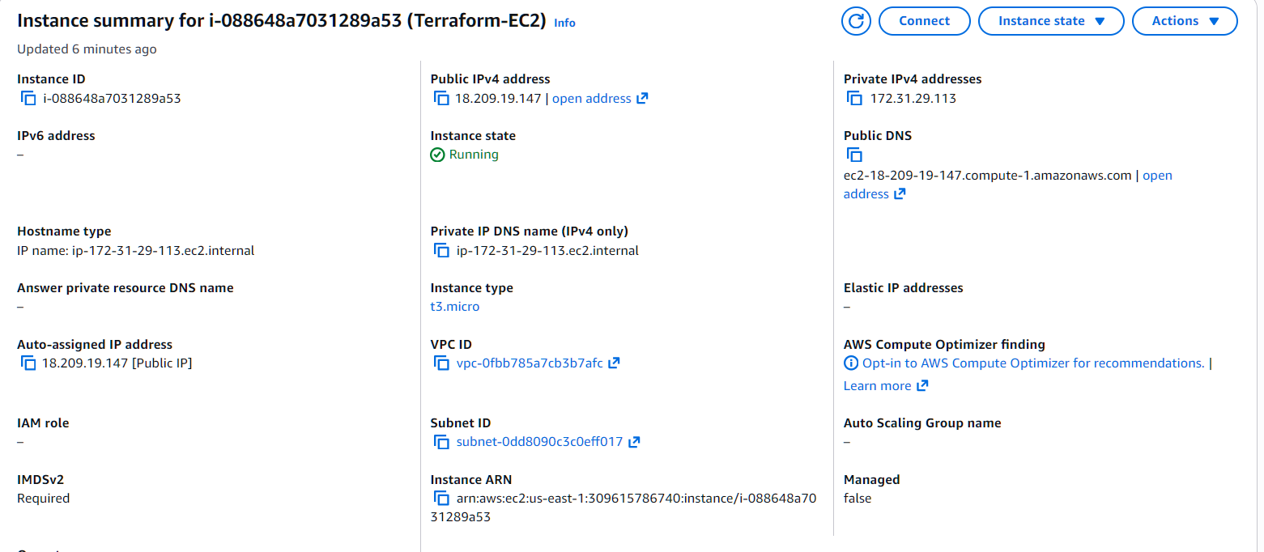
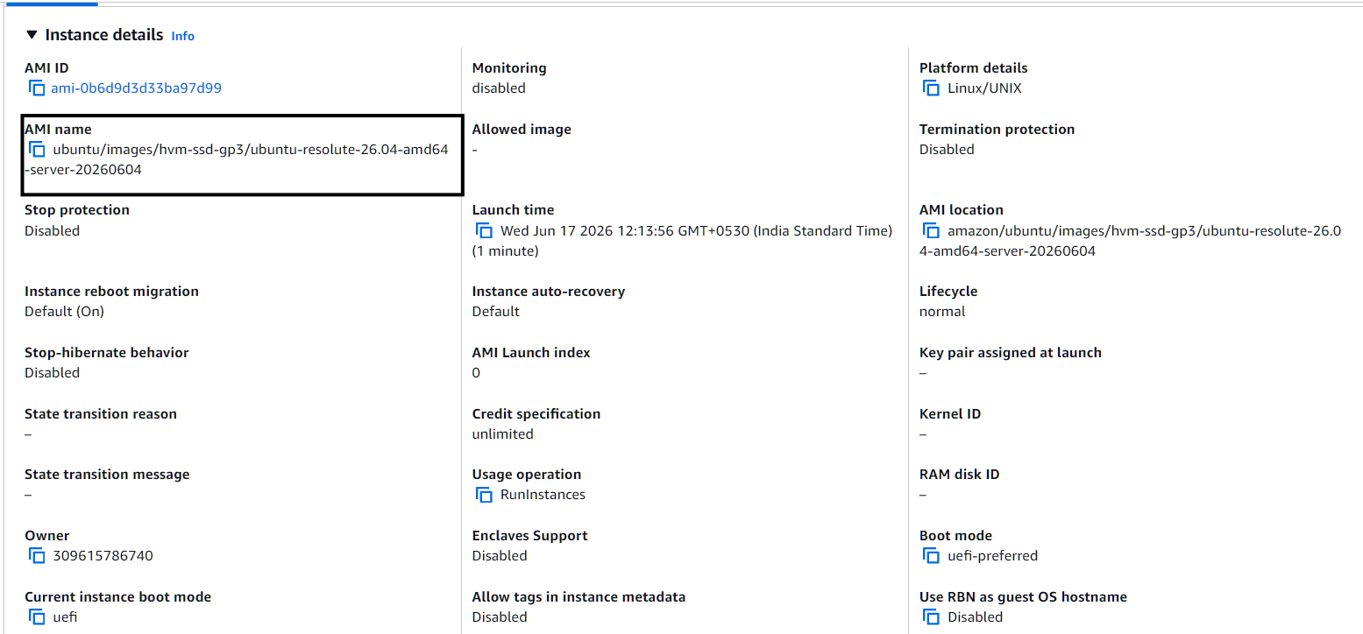

- Install a web server on the same EC2 Instance. The web server should listen on port 8080.
I have written a script to allow security groups port number 8080
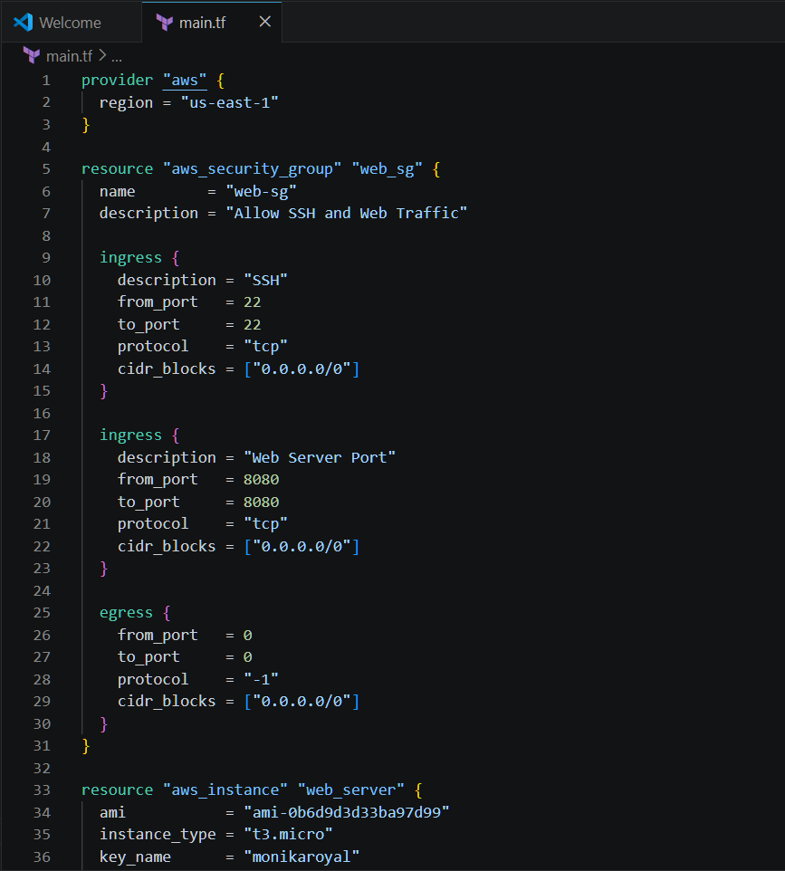

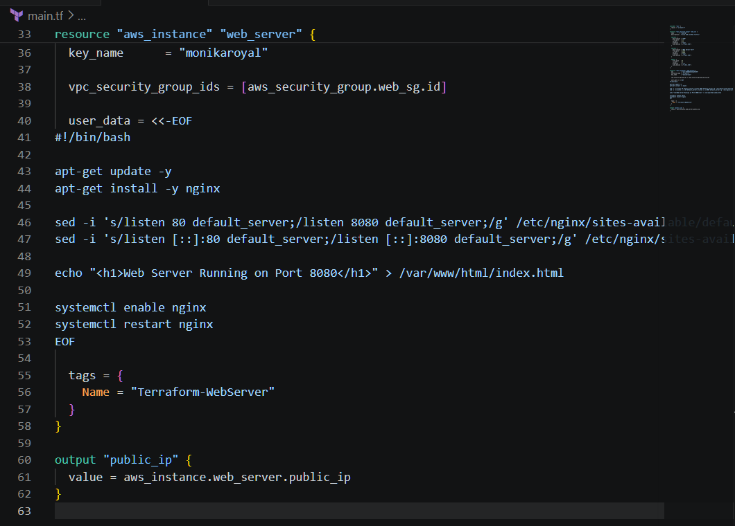
Performed terraform init
terraform plan
terraform apply
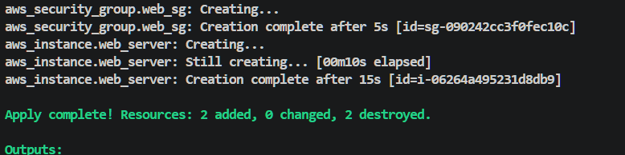
The web page is running successfully on port 8080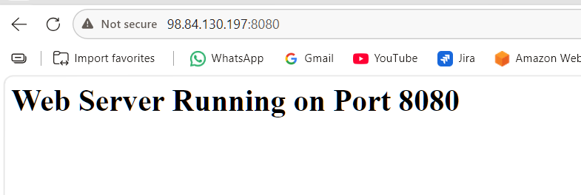
- Create a Docker-compose file for the project:https://github.com/betawins/cricbuzz-docker-hello-world.gitand point it to port 8000.

- Make the web server point to the above service so that 8080 returns the response from the Docker service.
Created a main.tf file
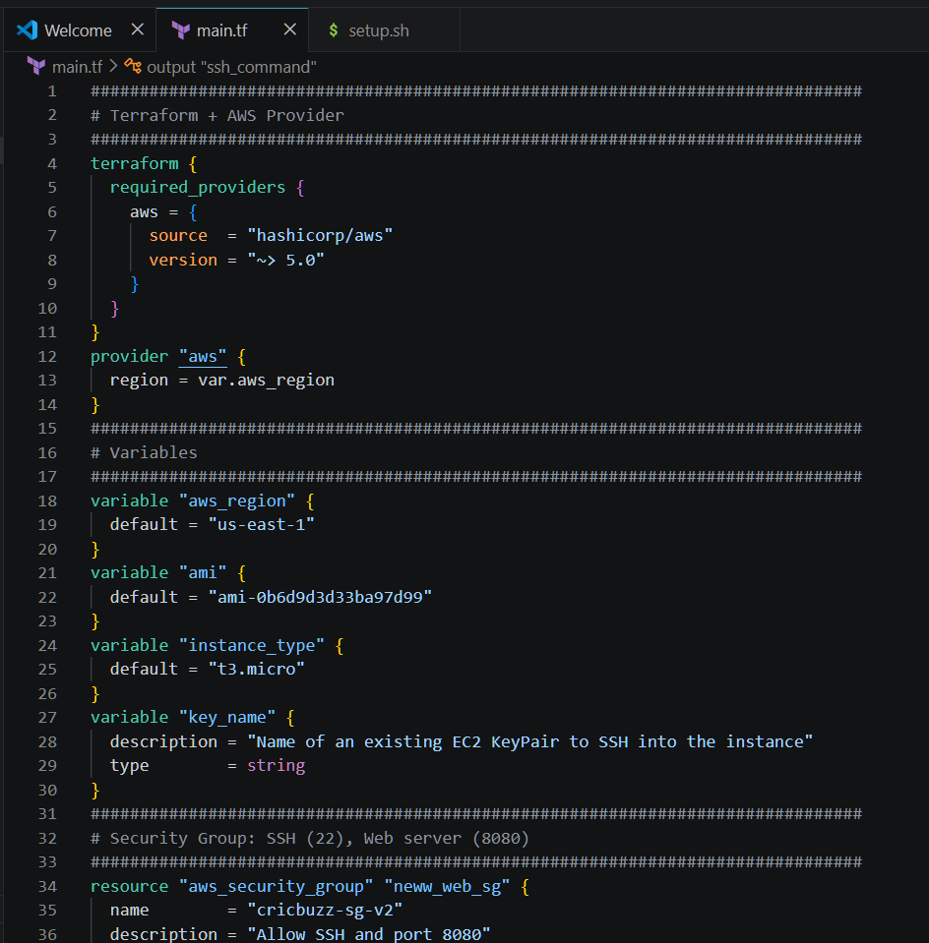
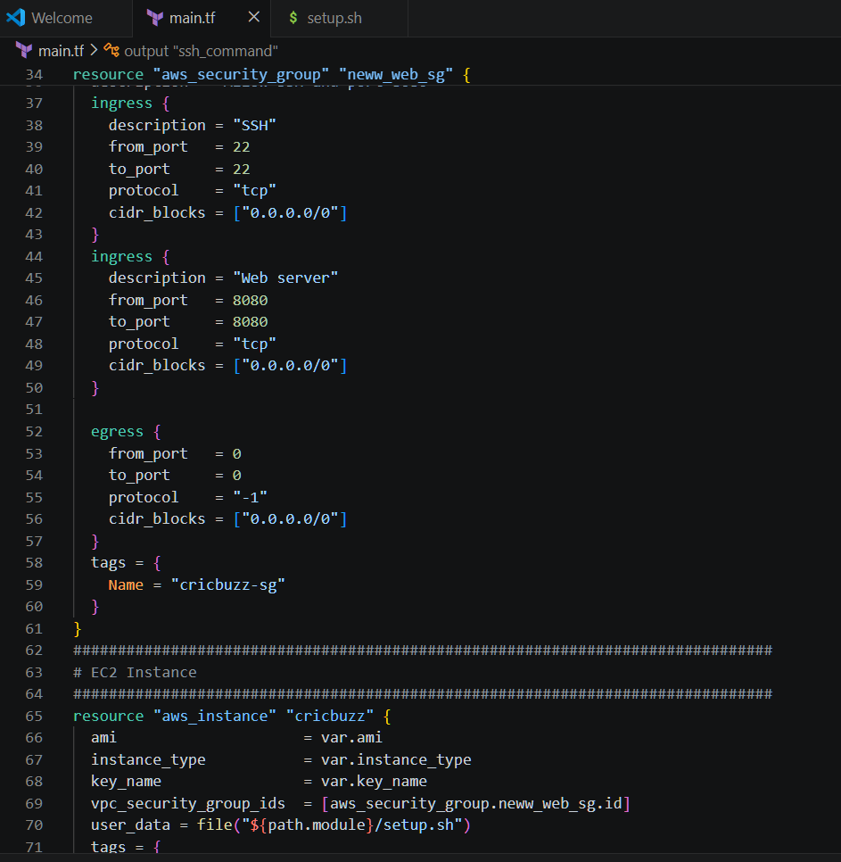
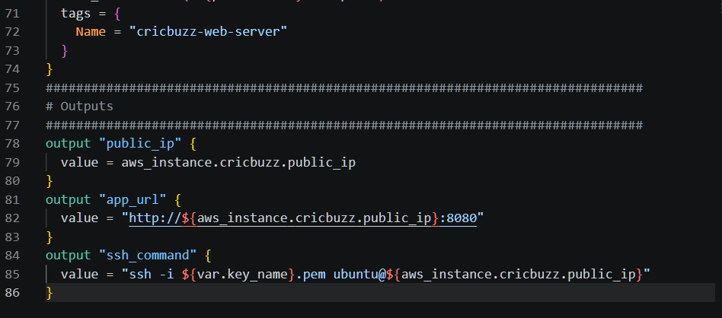
Created a setup.sh file
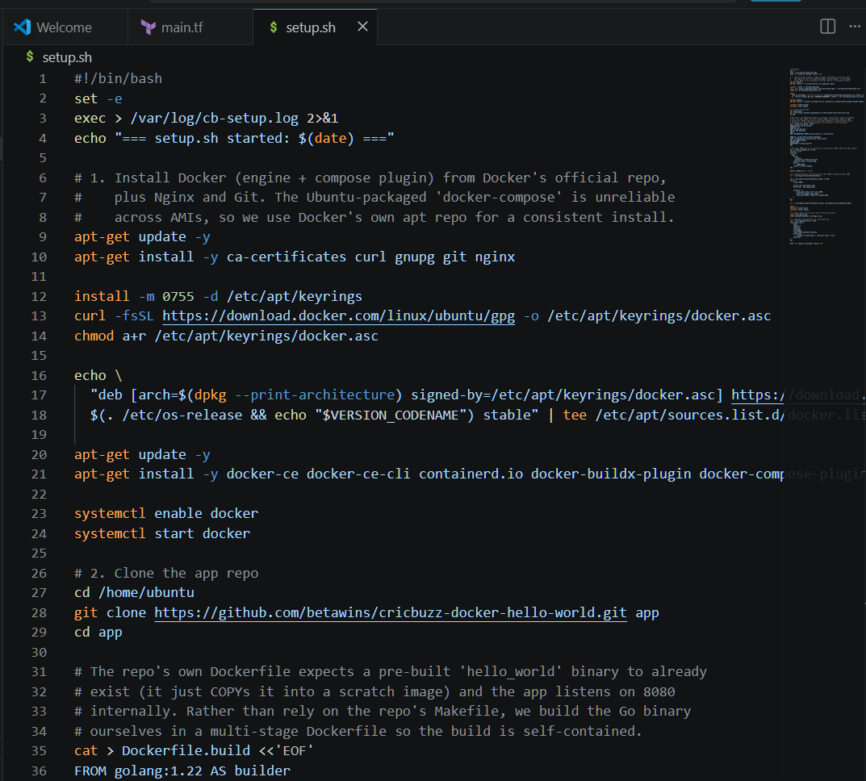
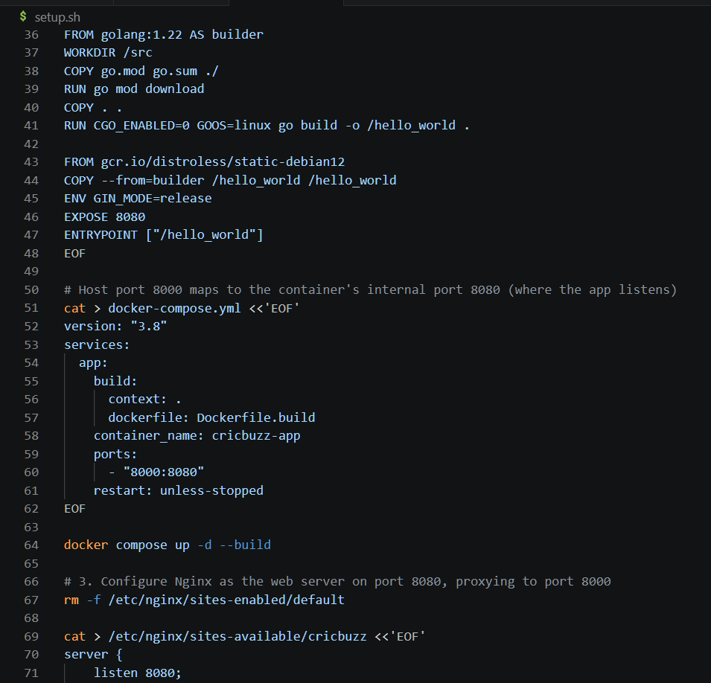
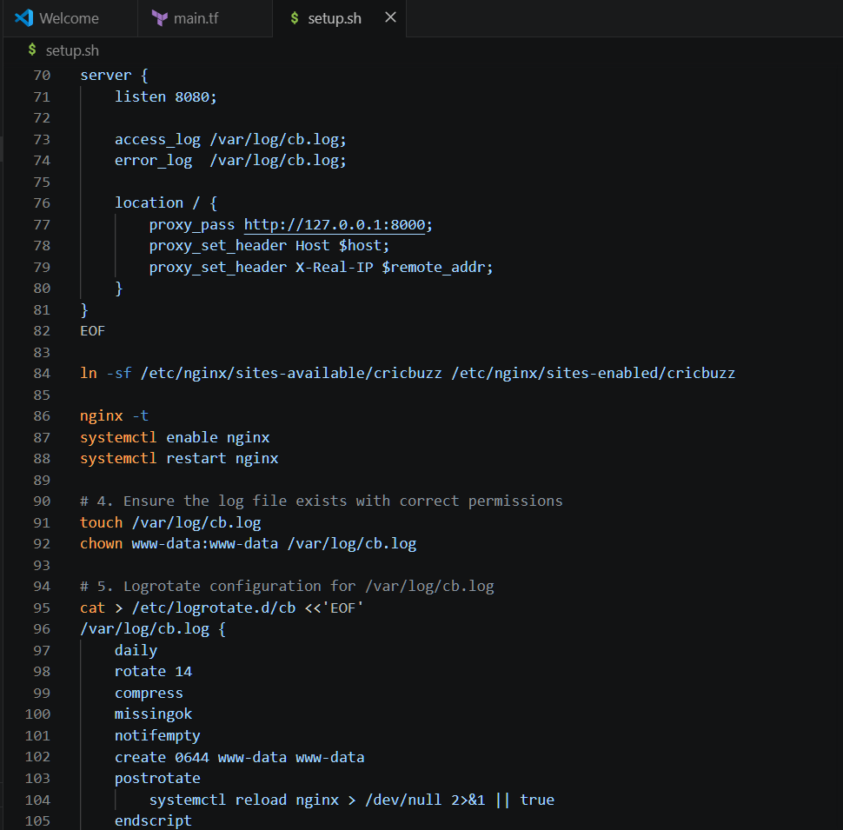
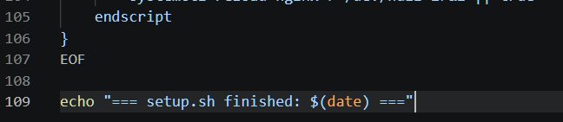
Performed terraform init
terraform plan
terraform apply
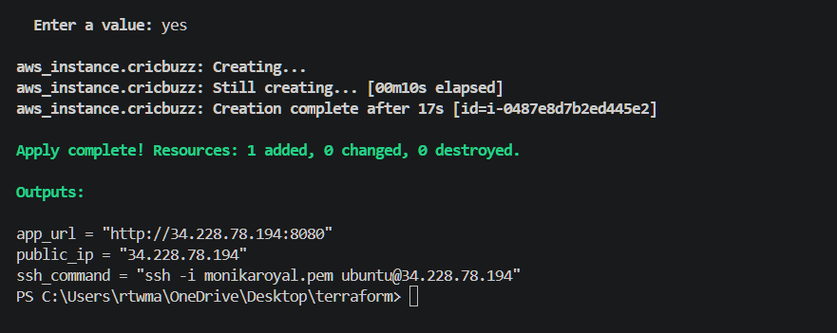
Instance created successfully
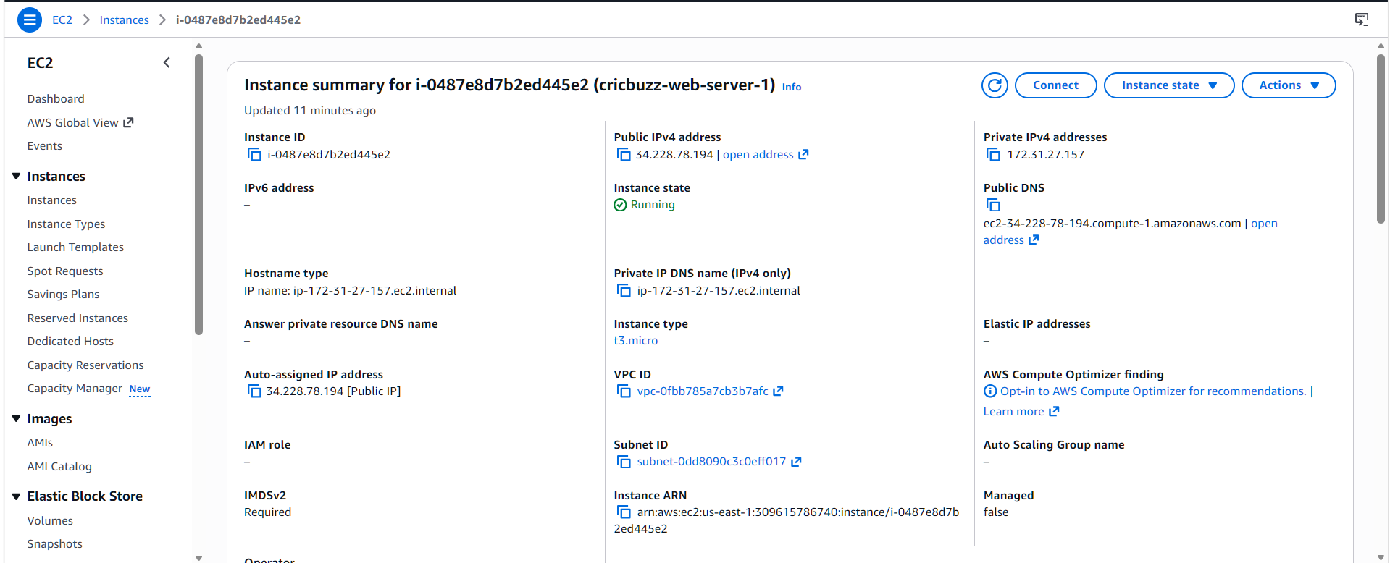

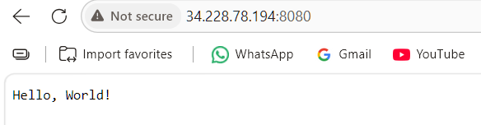

- Configure to Save the Logs in the location /var/log/cb.log
- Write the Log rotate configuration for the above file
we are able to see the logs
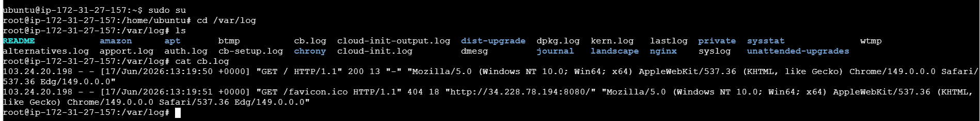
log rotate output
